**Anaconda Download and Installation with python 2.7:**

1. Go to : <https://www.anaconda.com/download/>
2. Select **Python 2.7 version** and download

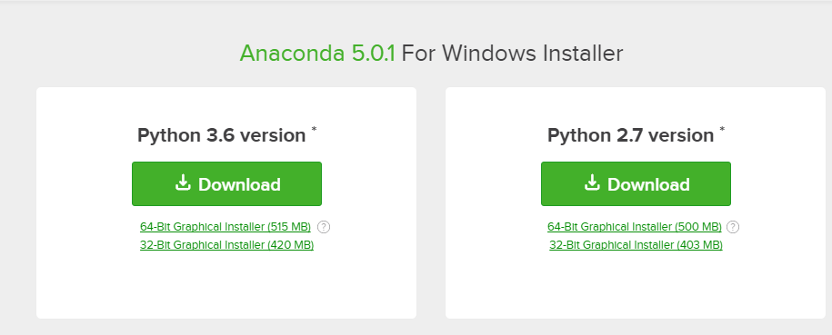

1. Double click on Anaconda2-5.0.1-Windows-x86_64.exe and run.

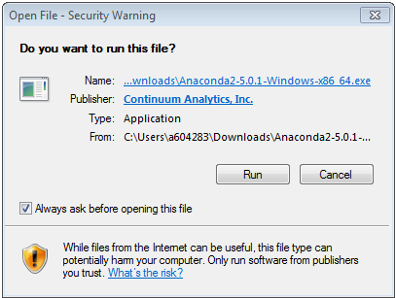

1. Follow the necessary steps and Anaconda will get installed within your system.
2. Go to Start menu and check:

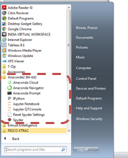

1. Congrats!! You are ready for coding in python.
2. Select Spyder or Jupyter Notebook as an interface.

**Courses including videos:**

<https://www.coursera.org/specializations/python> (Contains 5 courses)

<https://www.learnpython.org/>

<https://pythonprogramming.net/data-analysis-tutorials/>